September 2nd

Lab #1: Installing and using Linux
Lab 1 Report Due: 11:59 pm Sept. 10th
Fill in and submit using Canvas
Name: Alexander Cleveland

Installation Steps:
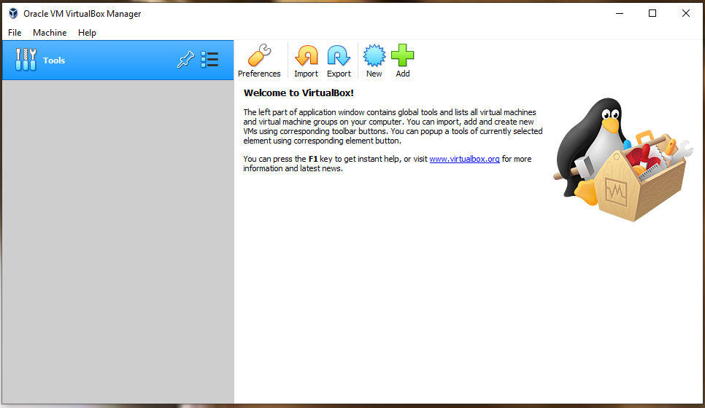
Step 1: Run VirtualBox
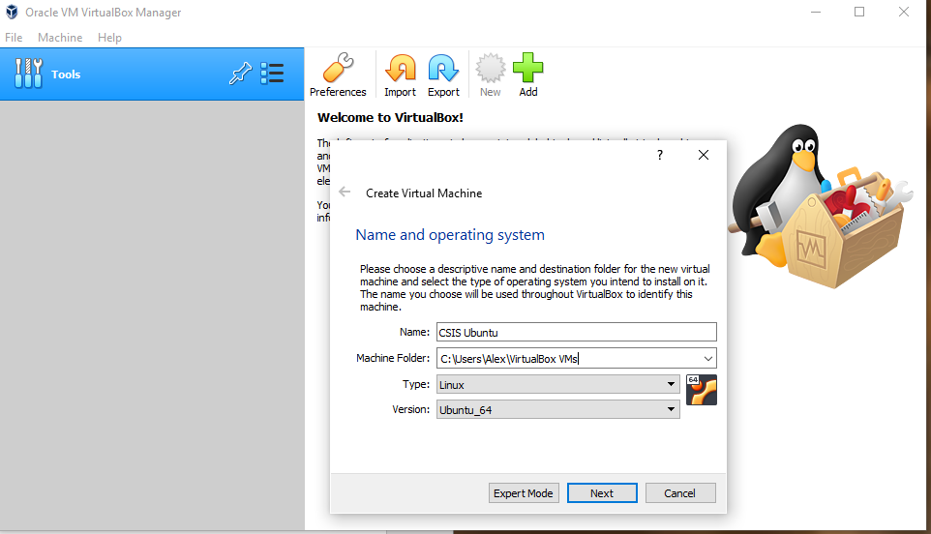
Step 2: Click on the New Button. Use the name “CSIS Ubuntu”. “Linux” for type and “Ubuntu (64 bit)” for version.
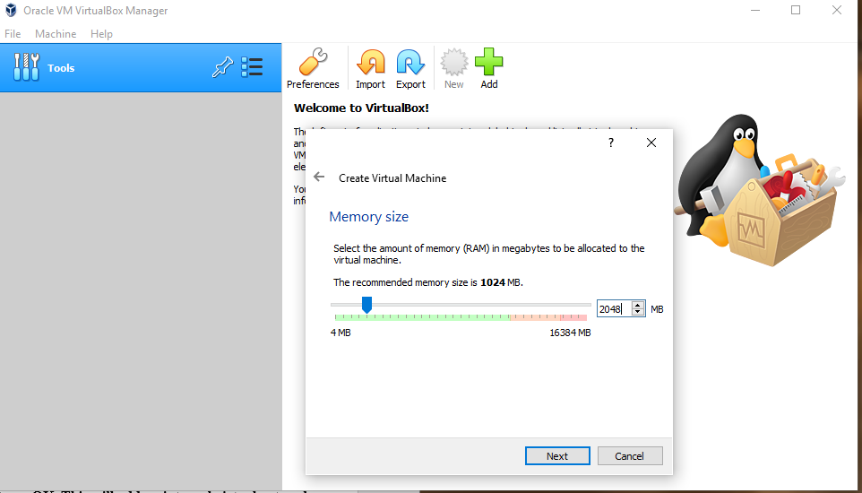
Step 3: Assign 2GB of memory to the VM.
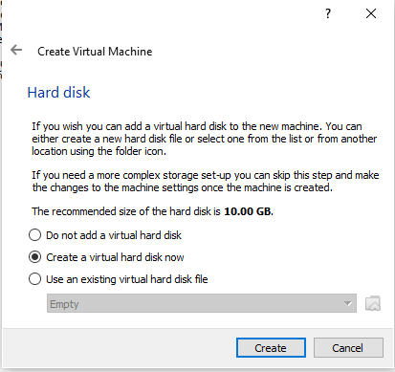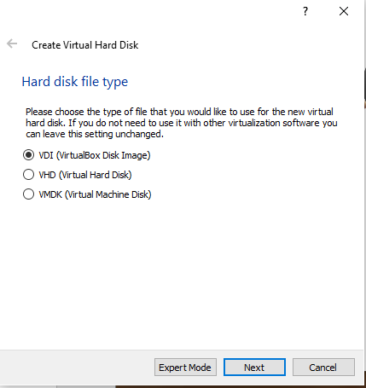
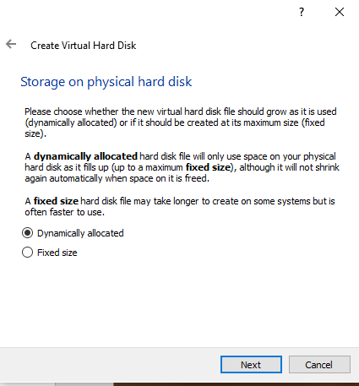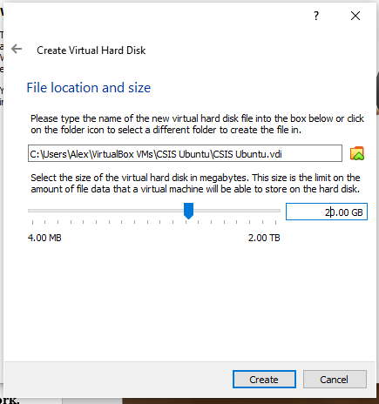
Step 4: Create a virtual hard drive now. Choose VDI and then choose Dynamically Allocated. Use the default name and set the size of the virtual hard drive to 20 GB.
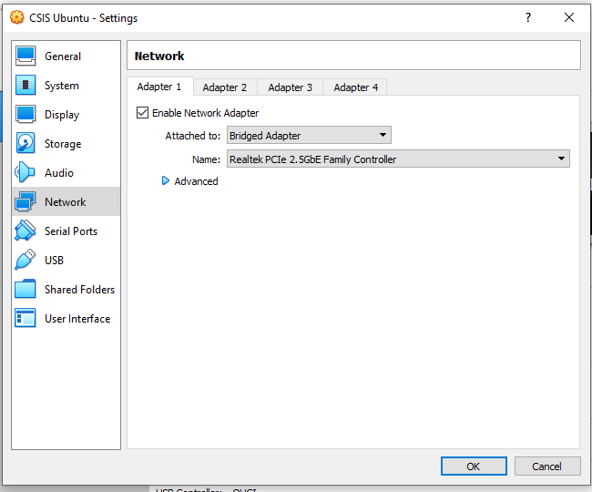
Step 5: Select Bridged Adapter in your VM’s Network Settings and this will make your VM appear as a new computer on your physical network.

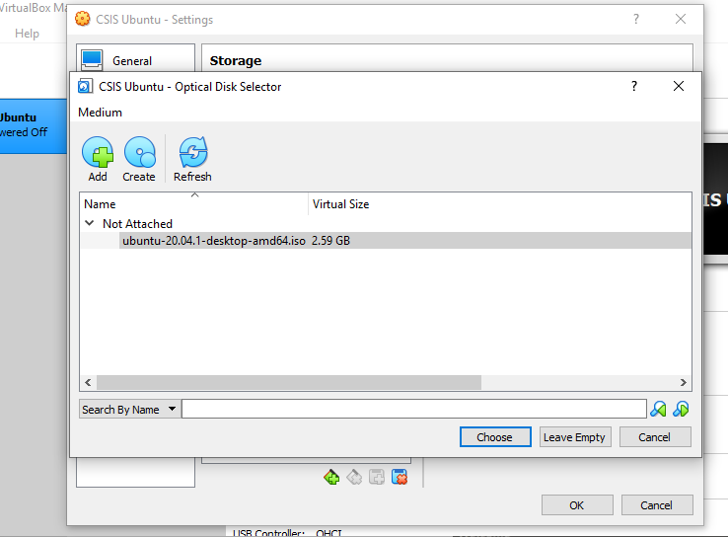
Step 6: Click on Settings→Storage and, Click on the “Empty” disk: In Attributes, click on the disk icon and select “Choose a virtual optical disk file” open the Ubuntu .iso file. Make sure to select the “Live CD/DVD” box.
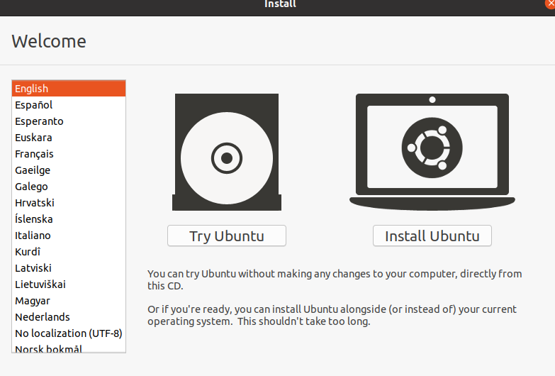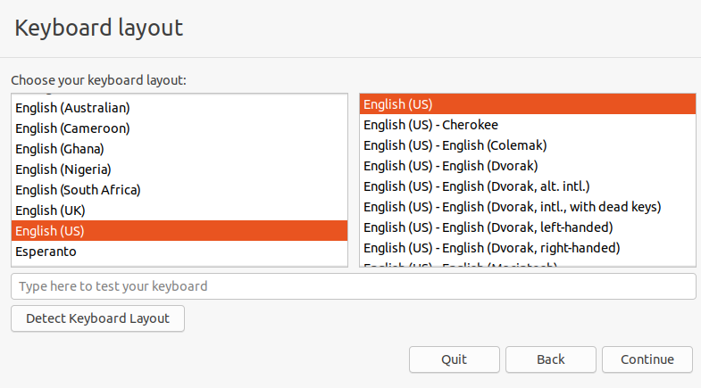
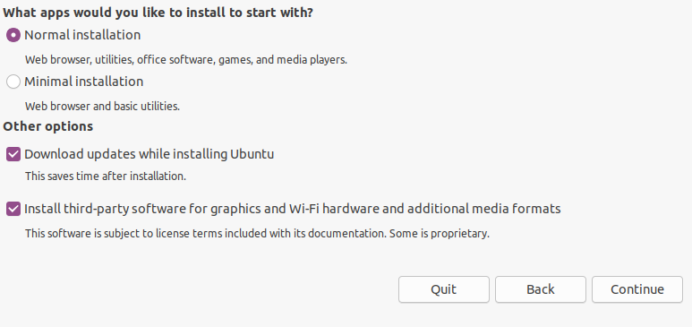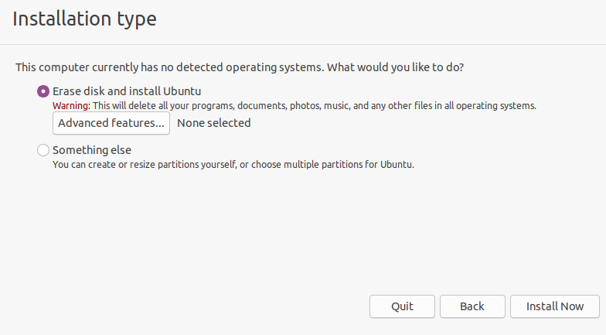
Step 7: Select “Install Ubuntu”. Choose “Normal installation”, “Download updates while installing” and “Install this third-party software”. Choose “Erase disk and install Ubuntu”. For time zone, choose Chicago or Central
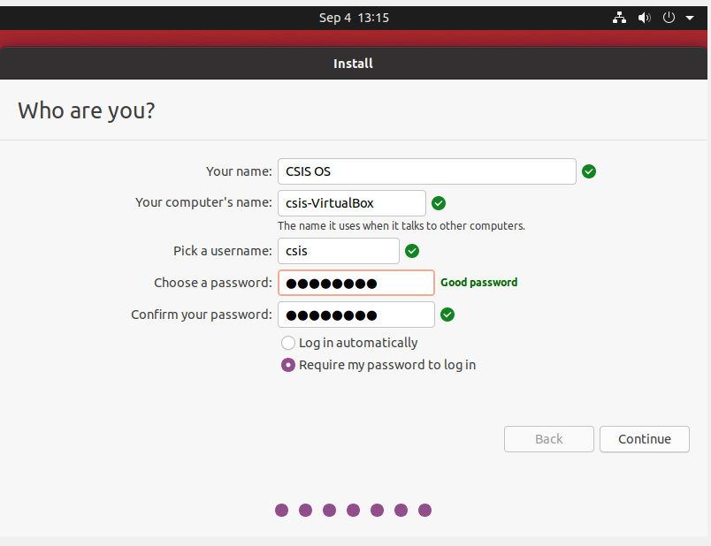
Step 8: Enter CSIS OS for Your Name and enter a name for the VM. Use the username csis and a password. Choose “Require my password to log in”.
Step 9: Remove the .iso file from the VM by clicking Settings → Storage → choose the ubuntu “dvd” under the IDE controller → click on the DVD and choose Remove Drive.

➢ sh<Enter>
➢ ps<Enter>
➢ bash<Enter>
➢ ps<Enter>
➢ pwd
What can you say about the output of the above 5 commands?
sh and bash do not have any outputs because they are command language interpreters and I did not give any inputs for those commands. Ps displays the active processes for example when all of these are run ps shows both sh and bash as active processes. Pwd prints your current directory which for me at the time I ran those commands was /home/csis/desktop.

➢ls
➢ls -l
➢ls -al
What is the difference between the above 3 commands?
Ls lists the files and directories in a directory, Ls –l will show more details on the files and directories and, ls –al will show all files and directories even hidden ones and show more details.

➢ cat > test.out
abcdef <Enter>
<Ctrl>d
➢ ls -l
What did the cat command do?
It wrote abcdef to a file called test.out.

➢ cp test.out test2.out
➢ ls -l
What did the cp command do?
It copied the contents of test.out to a new file called test2.out.

➢ rm test.out
➢ ls -l
What did the rm command do?
It deleted test.out.

➢ LS
➢ Ls
➢ Pwd
➢ PWD
What happened? Does this tell you anything about Unix commands?
The commands are case specific and these commands cannot be written in uppercase or a mix of upper and lowercase. These two commands can only be used in lowercase otherwise they will not be recognized as commands.

➢ mkdir testdir
➢ ls -l
➢ cd testdir
➢ pwd
What did the mkdir and cd commands do?
The mkdir made a directory called testdir and the cd command change my current directory to the testdir.

➢ mkdir testd2
➢ ls -l
➢ mv testd2 test1d
What did the mv command do? Why?
The mv command renamed testd2 to test1d because the test1d directory did not exist.

➢ rmdir testd2
➢ ls -l
➢ rmdir test1d
➢ ls -l
What did the rmdir commands do?
The first rmdir command fails because testd2 no longer exists and the rmdir successfully removes the test1d directoy.

Command for calendar for the entire year:
Cal –y
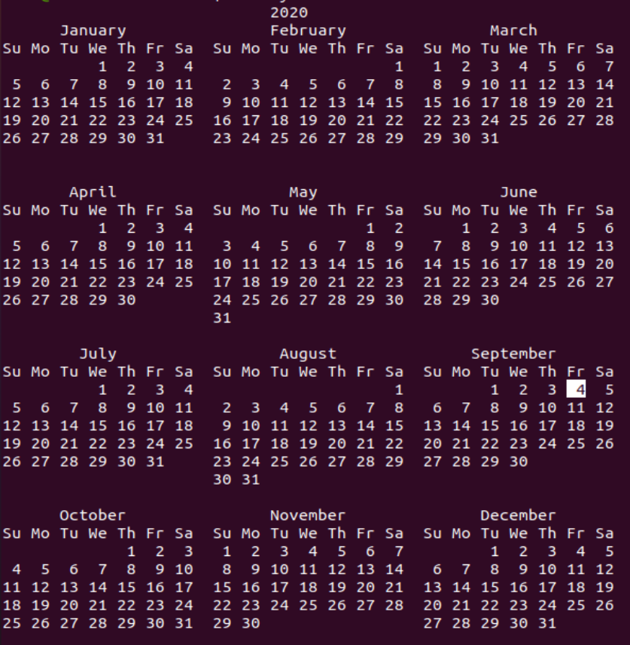

➢ who
➢ whoami
➢ id
Outputs:

➢ man script
What does the script command do?
The script command saves the inputs and outputs of the terminal in a file of your choosing if no file is specified then it will default to the file typescript.

➢ mkdir CS429
➢ cd CS429
➢ mkdir E2
➢ cd E2
➢ pwd
What does the output of the pwd tell you about the commands you entered before it?
It tells me that the mkdir command can only be used in the current active directory.

Output of script part2:
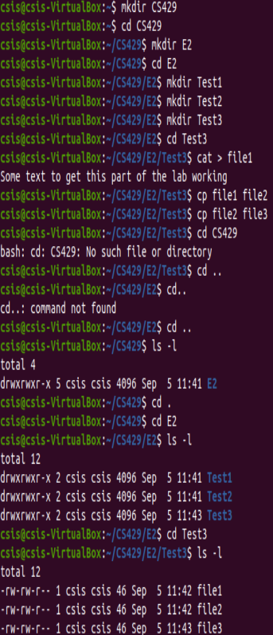
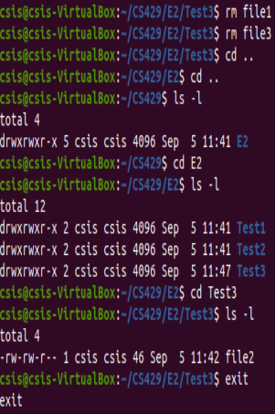

What kind of “files” does the /dev directory have?
The /dev directory mostly contains block and charater special files. The remaining ones appear to be link files and directories that contain more block and character special files.

- ln ~/CS429/E2/test/file2 c1
- ln -s ~/CS429/E2/test/file2 c2
What did the above commands do?
The commands created two files that are both linked to the file file2.

Use the 'ls -l', file, and stat commands to look for as any differences between c1 and c2 as you can find; in your report, write down all the important differences you observed.
Upon using the ls –l command it is revealed that c2 compared to c1 is a link file with the execute permission enabled. Upon using the file command it is revealed that c1 is a ASCII text file and c2 is a symbolic link to the file file2. Below are the outputs for the stat command on both files notice that files are completely different except for the Birth, device, user id, and group id.
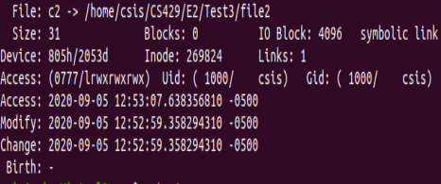
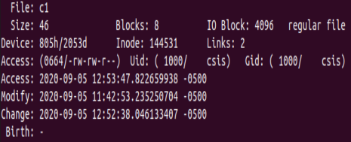
For each of the commands from ps to monit listed below, use your own words without copying and pasting from the man pages or elsewhere to describe briefly (25 words or less) in your report what each command does, indicate whether you have used this command in the past and how familiar you are with it.
➢ ps: Displays all of the active processes with options to see the processes in different syntaxes or to view certain information about a process.
➢ pstree: Displays all active processes in a tree format with options to change the format and look of the tree.
➢ top: Similar to ps top displays all active processes but unlike ps, top will display all active processes in realtime.
➢ htop: Allows more interaction with processes window as well as allow you to view the processes in the tree format.
➢ vmstat: Gives information about processes including memory and cpu usage
➢ df: Gives the amount of diskspace being used by every filesystem.
➢ du: Gives the amount of diskspace being used by files.
➢ iotop: Displays I/O usage for the read and write of each active process.
➢ iostat(sudo apt-get install sysstat): Displays CPU statistics and monitors I/O for devices and partitions.
➢ lsof: Display all open files.
➢ netstat(sudo apt install net-tools):Diplays all network connections, routing tables, Interface stats, etc.
➢ vnstat: Allows user to moniter network traffic over a minimum 5 minute interval to a maximum interval of yearly.
➢ nethogs: Allows user to see what process is using the most bandwidth on their network.
➢ monit:Automated program that monitors filsystems, directories, files, programs, and processes and fixes any errors that may occur. It will also restart processes that are not responding or terminate processes if they are using to many recourses.

